**BDD Testing Overview for Team Scrumdiddleyumptious Sprint #2**

# Overview

Cucumber and Selenium were used to automate BDD tests. Three BDD scenario tests were created to validate the three stories completed in this sprint.

1. Visit the application
2. View application welcome and instructions
3. View the class list

# Feature Files

## BDD Feature File #1 (Home Page)

2 scenarios are in the Home Page feature file

1. Visit the application
2. View application welcome and instructions

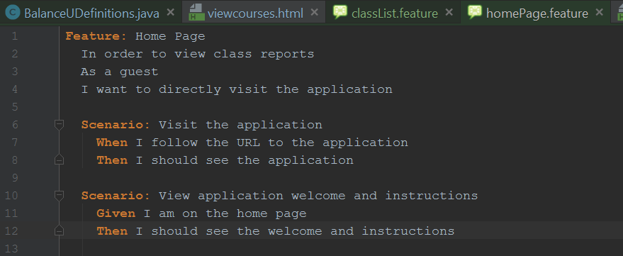

Step Definition for “Visit the application”

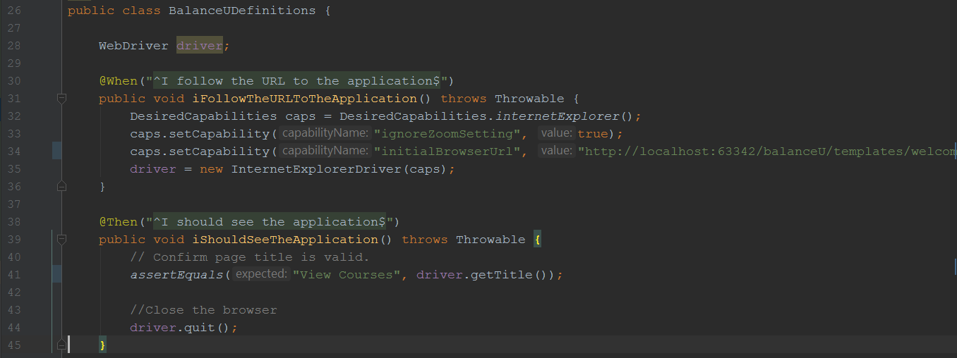

Step Definition for “View application welcome and instructions”

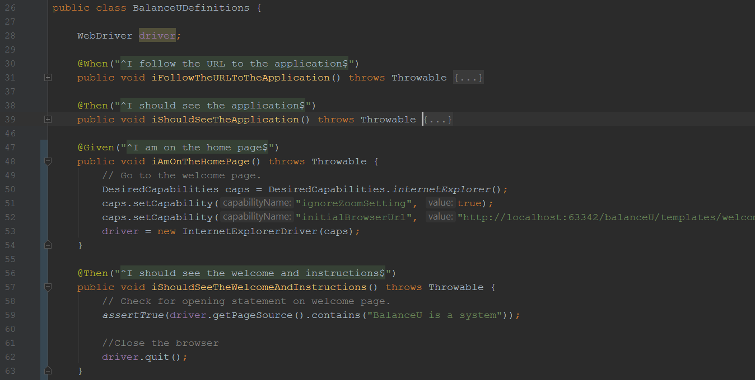

## BDD Feature File #2 (Class List)

1 scenario is in the Home Page feature file

1. View the class list

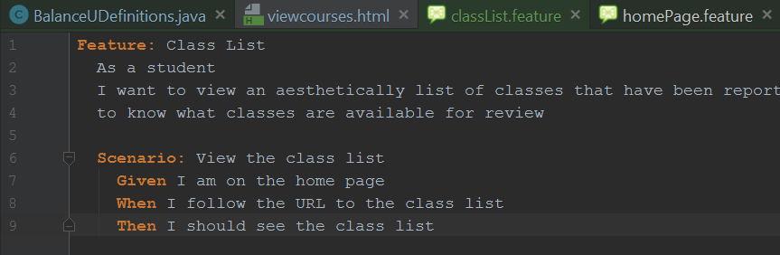

Step Definition for “View the class list”

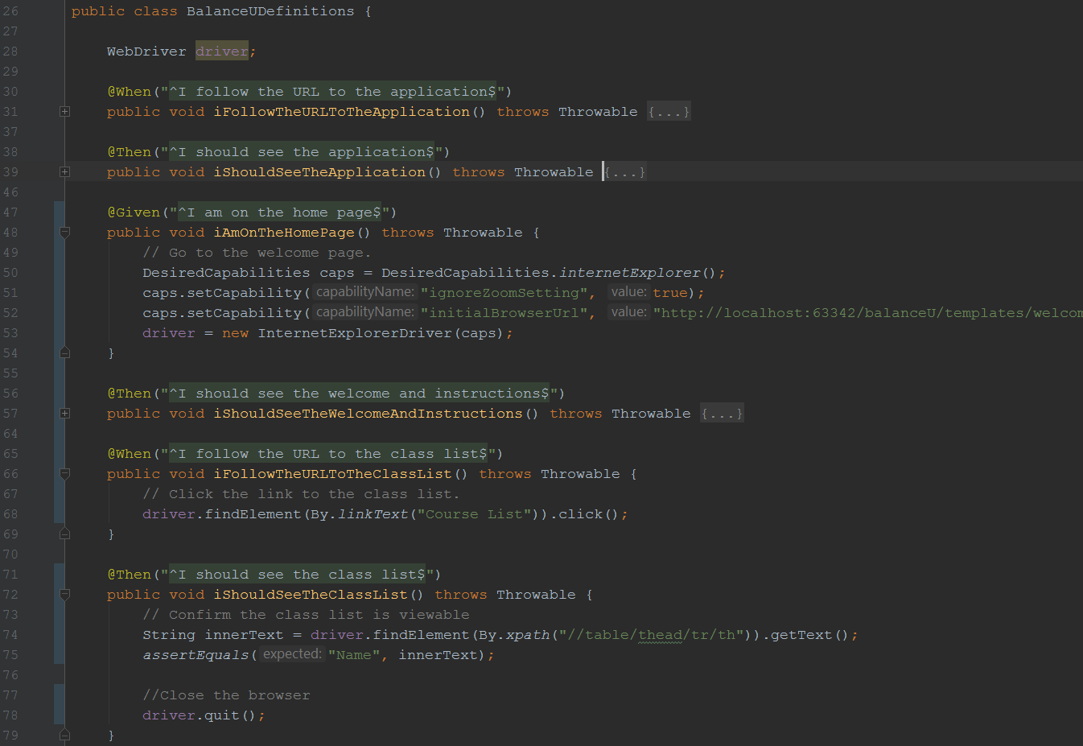

# BDD Test Run Results

All 3 BDD tests ran using Cucumber and Selenium and passed.

